  Complete a book review of a book you have read during the summer. | Practise your number formation to 10. |   Cook a dish with an adult.  Can you write a set of instructions for your class? | Practise your RWI phonics.
  Summer holiday snapshots.  Complete 5 drawings of your summer holidays. Write a diary entry for one of these snapshots. | Go on a nature walk and create your own ‘journey stick’. | Learn as many spellings from the year 1 spelling list as you can. | 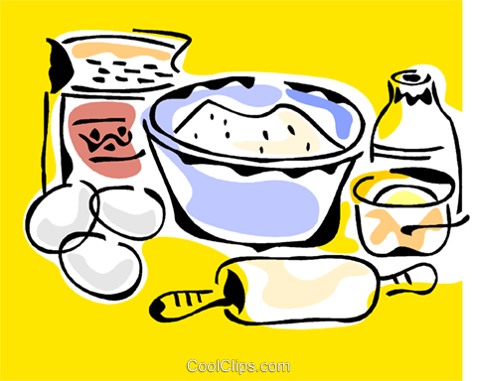  Bake a cake and measure the ingredients.
  Write a letter to your new teacher with the  help of an adult. | Create a fact file about your favourite animal. | Draw your own giant pumpkin. What could you use it for?   | Ask your family and friends what their favourite fruit is. Make a tally chart.


Welcome to year 1! Below are some activities children can choose do to at home, they can do as many as they wish.
Children may also come up with their own ideas, even if it is not on this sheet. Remember, in addition to this there is the local library’s Summer Reading Challenge, MyOn and TT Rock Stars.

