

Year 6 -Summer Term Project

All Around The World  Research a country, and present it as diorama!    - food  - landmarks  - language  - sport, famous people  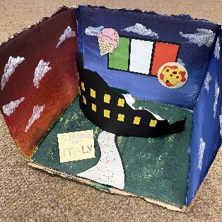  - flag | GET ACTIVE!    30 seconds of work and 30 seconds rest! |   STEAM CHALLENGE  Pick one or more!  Design the Ultimate Survivor – Create and label a new animal that is perfectly adapted to survive in a chosen habitat (desert, rainforest, Arctic, ocean, etc.).  Shadow Puppet Theatre – Create your own shadow puppets and perform a short story using a torch.
  X3!!!  Exercise | What to do
  Star Jumps | Keep moving continuously.
  Press-ups | Full or knee press-ups.
  High Knees | Lift your knees as high as you can.
  Squats | Sit back as if you're sitting on a chair.
  Mountain Climbers | Keep your core tight and move quickly.
  Build an Evolution Timeline – Create a timeline showing how one animal has changed over millions of years.
Kindness Challenge  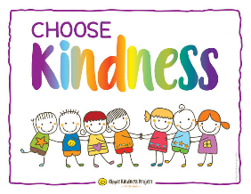  - Help a neighbour  - read to sibling  - donate toys  - thank-you card  - help with housework  - pick up litter  Maths mission  Get familiar and challenge your arithmetic skills:  https://corbettmathsprimary.com/content/ | My Year 6 Goals…  This year I want to...  ⭐ Improve...    ⭐ Be brave enough to...  ⭐ Make friends with...  ⭐ Achieve...  ⭐ Try... | Writing/Reading Challenge:  • Write a letter to your favourite character.  • Create a narrative.  •Create a newspaper article.  - Diary entry- Your summer so far…  - Write a letter to your future year 6 self explaining your hopes, goals and what you are looking forward to.  Bonus: Take a selfie reading in unusual places.    Examples:  • The Best Day of My Summer  • My Dream Secondary School  .




