MissionGrove

P R I M A R Y S C H O O L

RESPECT YOURSELF RESPECT OTHERS

Headteacher | Miss Katie Jennings

2nd June 2026

Dear Parents/Carers,
Year 6 Swimming
As part of the National Curriculum, children should be taught to swim competently, confidently and proficiently over a distance of at least 25 metres. They should learn how to use a range of strokes effectively.
To enable the children at Mission Grove to have the best possible chance of achieving this, we take children throughout their time at school.
Monday 8th June – Friday 12th June: Buzzard (10am – 11am- leaving school at 9:30am)
Monday 8th June – Friday 12th June: Blackbird (13:00 – 14:00- leaving school at 12:30pm)
Monday 8th June – Friday 12th June: Barn owl (14:00 – 15:00- leaving school at 13:30)

The children will have lunch at school and walk to the Feel-Good Centre.
The children will need:
- A towel
- A swimming costume / trunks (not board shorts)
- Goggles
- A swimming hat
- Optional – a small healthy snack- a piece of fruit would be ideal
Please make sure that your child does not wear any jewellery for the week of swimming.
Yours faithfully,
Miss Katie Jennings.

North Site | Buxton Rd | Walthamstow | London | E17 7EJ |
South Site | 108 Edinburgh Road | Walthamstow | London | E17 7QB
T : 020 8520 3487 | F : 020 8520 8409 | E : office@missiongrove.org.uk

Towel:

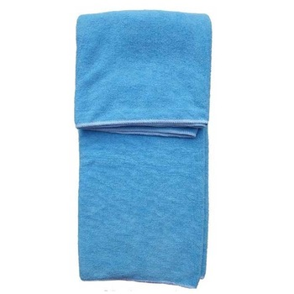

Swimming costume:

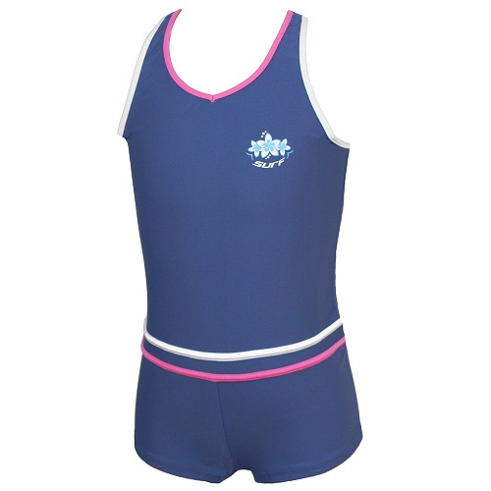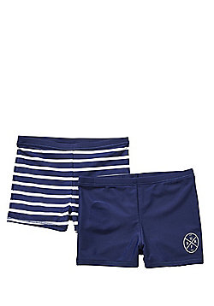

www.missiongroveschool.com

Goggles:

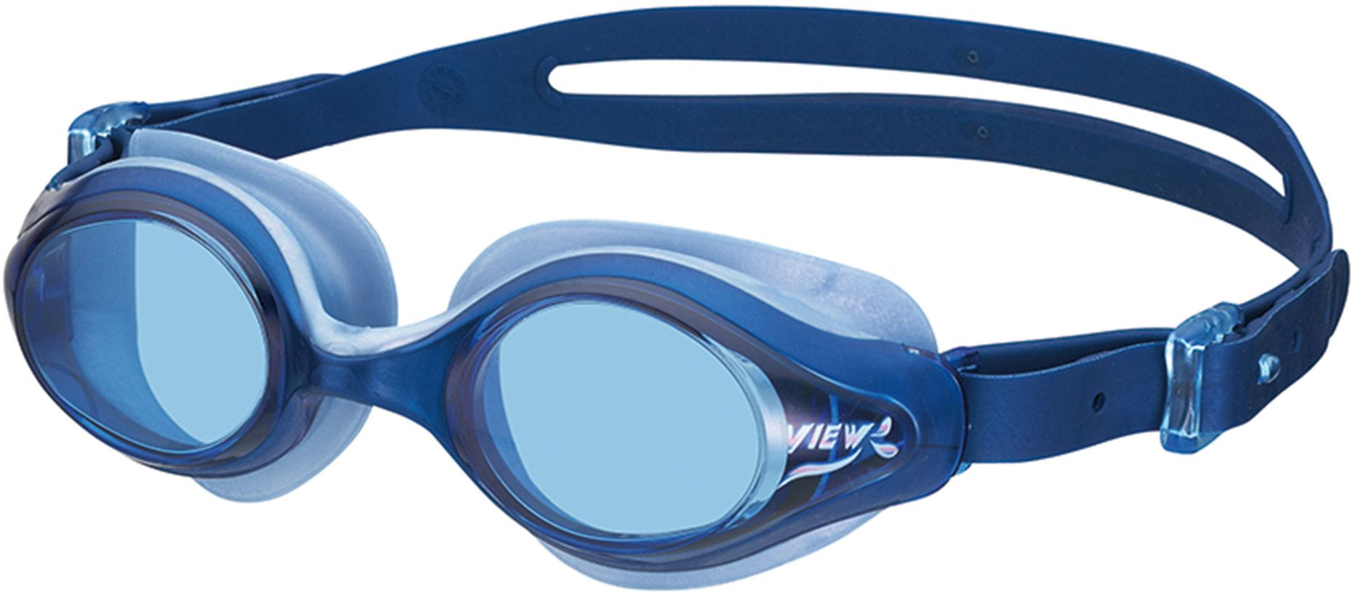

Swimming cap:



