MISSION GROVE PRIMARY SCHOOL YEAR 3 Spring Term 2 Earthquakes, Volcanoes and Mountains

Experiences – Library trip, World Book day, Kestrel class assembly, STEAM week, V & A trip, Happy Puzzle workshop, Kittiwake Assembly

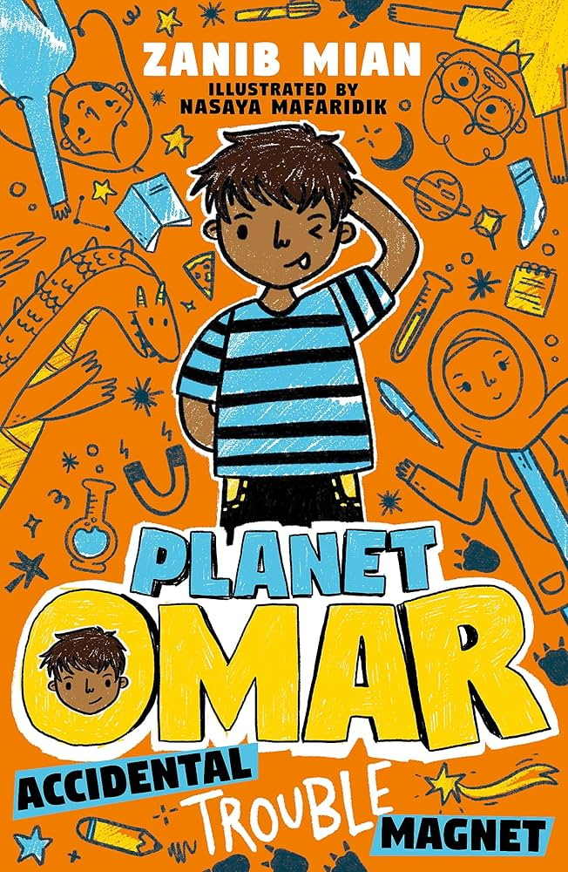
Power Maths

Fractions
This unit is important as it builds on many of the topics covered in the Year 2 unit on fractions and progresses to introduce fractions as numbers. Throughout the unit children use a variety of key representations, including the bar model and the number line, to help their understanding as they make a whole out of two fractional parts, explore tenths and fractions as a number, and calculate a unit and non-unit fraction of a set of objects.

Mass
First, children will learn how to measure and read a scale, focusing upon unmarked intervals. Next, different masses will be compared and ordered. Following this, children will learn to add and subtract different amounts using a range of strategies. Finally, they will apply their knowledge to real-life problems – an important skill for children to learn in order to work towards mastery.

Capacity
This unit explores capacity and comes after other units about measure. It asks children to interpret a range of scales and apply their knowledge of place value and the number system. Children will learn to compare and order measurements, and convert between millilitres and mixed units of litres and millilitres. They will then use knowledge of all four operations to solve problems involving capacity.

Class Text – Planet Omar by Zanib Mian
Genres for writing – Poetry, narrative and character descriptions.
Alternative texts:
Golden Domes and Silver Lanterns, Hena Khan and Mehrdokht Amini
(Chronicle Books)

Writing
- discussing writing similar to that which they are planning to write in order to understand its structure, vocabulary and grammar
- discussing and recording ideas
- organising paragraphs around a theme
- in narrative, creating setting, characters and plot
- proposing changes to grammar and vocabulary to improve consistency, including the accurate use of pronouns in sentences
- proofread for spelling and punctuation errors
- read aloud their own writing, to a group or the whole class, using appropriate intonation and controlling the tone and volume so that the meaning is clear
Reading
- Increase familiarity with a range of books;
- Identify themes and conventions;
- Show understanding through intonation, tone, volume and action;
- predicting what might happen from details stated and implied
- identifying main ideas drawn from more than one paragraph and summarising these
- preparing poems and play scripts to read aloud and to perform, showing understanding through intonation, tone, volume and action

French
Le Corps
The children will be looking at French phonics, body parts, colours and using adjectives.
Speaking and Listening
Listen and respond appropriately to adults and their peers
▪ Ask relevant questions to extend their understanding and knowledge
▪ Use relevant strategies to build their vocabulary
▪ Articulate and justify answers, arguments and opinions
▪ Give well-structured descriptions, explanations and narratives for different purposes, including for expressing feelings.

SCIENCE – Animals including humans
Children will learn:
- identify that animals, including humans, need the right types and amount of nutrition, and that they cannot make their own food; they get nutrition from what they eat
- identify that humans and some other animals have skeletons and muscles for support, protection and movement
- STEAM week: life size board games

Physical Development
Ball Skills
In this unit pupils have opportunities to develop a variety of ball skills without the restrictions of specific rules related to well-known games. They will develop their accuracy and consistency when tracking a ball, explore a variety of throwing techniques and learn to select the appropriate throw for the situation. They will develop catching with one and two hands as well as dribbling with feet and hands. These skills are applied to small group games. Pupils will have the opportunity to take on different roles and work both individually and with others.

Yoga + Ballet

Pupils discover how yoga can help them to develop balance, strength and flexibility. Pupils learn and explore yoga poses that will challenge each of these and work independently and with others to create their own yoga flows with consideration to how the poses are sequenced.
As well as building movement skills, pupils will also develop appreciation for music, artistry (presentation skills) and the ability to work cooperatively with other members of their class.

Computing
Data and information - Branching databases
Learners will develop their understanding of what a branching database is and how to create one. They will use yes/no questions to gain an understanding of what attributes are and how to use them to sort groups of objects. Learners will create physical and on-screen branching databases. To conclude the unit, they will create an identification tool using a branching database, which they will test by using it. They will also consider real-world applications for branching databases.

PSHE - Jigsaw
Healthy Me
In this Puzzle, the children learn about the importance of exercise and how it helps your body to stay healthy. They also learn about their heart and lungs, what they do and how they are very important. The children discover facts about calories, fat and sugar; they discuss what each of these are and how the amount they consume can affect their health. The children learn about different types of drugs, the ones you take to make you better, as well as other drugs. The children consider things, places and people that are dangerous and link this to strategies for keeping themselves safe.

Humanities
Geography – Earthquakes, Volcanoes and Mountains
- The children will be learning about tectonic plates, what they are, how they move and what happens when they move.
- They will explore how mountain ranges and volcanoes are formed, comparing their features and locating those using maps.
- The children will be exploring where earthquakes and volcanic eruptions are most likely to take place and what the impact can be for the human population in those areas.

RE
L2.5 Why are festivals important to religious communities?
This investigation enables pupils to learn in depth from different religious and spiritual ways of life as shown through festival and celebration. This unit enables pupils to begin to understand how celebration reminds believers of key beliefs and gives time to focus on beliefs and commitments and celebrating as a believing community. The focus is on the key elements of festival-shared values, story, belief and hopes and commitments.

Art and Design & Technology
Music:: The Dragon Song

Art – Focusing on Collage and Painting (Nick Rowland)

DT – STEAM week

