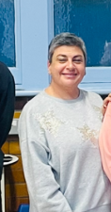
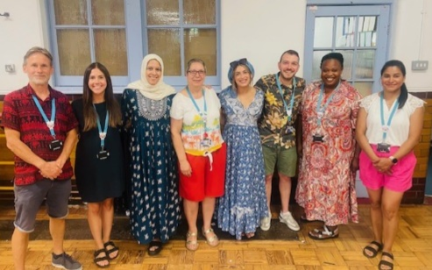

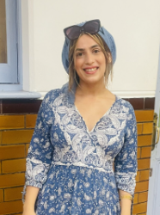
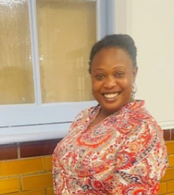
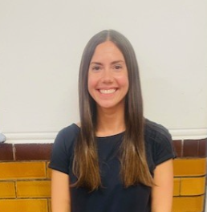
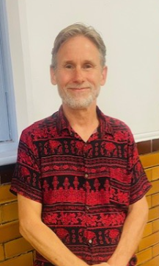
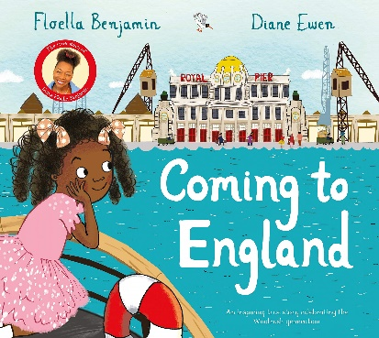
To help you feel prepared and excited to start your new class in September, we have included some information for you!

Meet the team …
My name is Ms Hakeem and I am the Year group lead for Year 3. Mr Conor, Ms Mae, Ms Zehra, Ms Claudia and Ms Tahira are the Teaching Assistants for Year 3 and will be working with individuals and groups of children throughout the year.
I am Ms Hakeem (Science and year group lead) and I am the class teacher for Kestrel class. Additionally, I will be joined by Ms Minasse who will be undertaking teacher training.

If you have any questions about this year, or would just like to come and introduce yourself, then please do not hesitate.

Thank you 😊

I am Ms Thompson and I will be based on North site teaching Kittiwake Class.
I am Ms O’Brien and I will be based on North site teaching Kingfisher Class.
I am Mr Gwynn-Jones and I will be based on South site teaching Kinglet Class.
Autumn 1

Maths: Place value and four operations

Literacy: Diary Entry, letter writing and autobiography

Science: Plants

History – Windrush

Computing: Computing systems and network

Art: Drawing landmarks

RE: What does it mean to be a Hindu in Britain today?

Pshe: Being me in my world

Music: Let your spirit fly (charanga)

PE: Handball and Tag rugby

Our core text for this term is:
Welcome to Year 3 Aim high, Succeed and be happy!

