

Welcome from the Year 4 team!

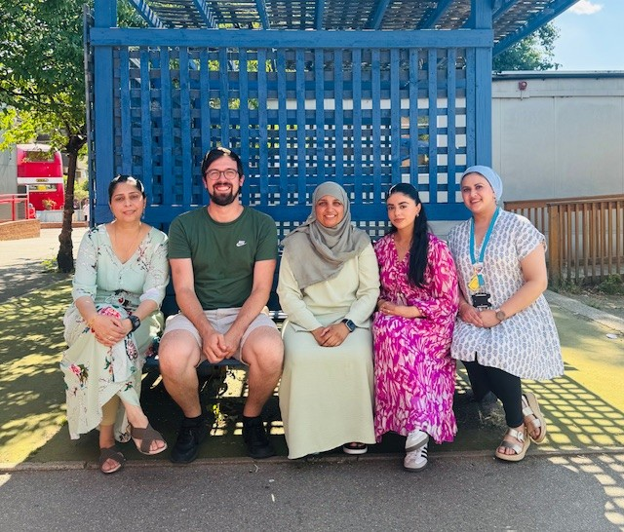
To make you feel prepared and excited to start your new class in September, we have included some information for you to get to know your new year group!

Expectations:

Spellings: To be familiar with the National Curriculum statutory spelling list for Year 4.

Handwriting expectations: All letter joins are correctly formed, with accurate ascenders and descenders. Suitable and consistent size of handwriting.

Behaviour: Childrens’ behaviour should reflect our Rights Respecting school values.

Woodpecker: Ms.Ahmed (Head of Year)
Wagtail: Ms.Lambat
Waxwing: Mr.Lester
Wren: Ms.Yasin
Support staff: Brenda, Sharman, Al-Sabah, Farzana, Mariam






In Autumn 1 we will be reading…


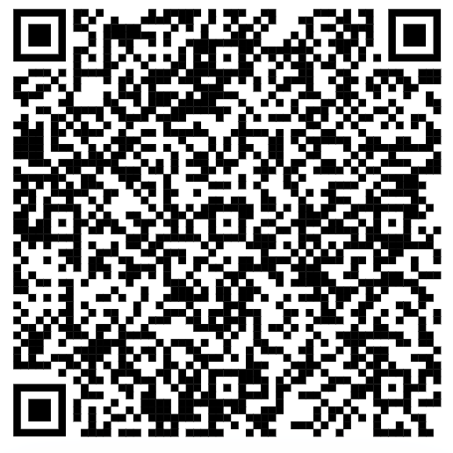 | AR Reading:  Over the summer keep reading books and completing quizzes.  
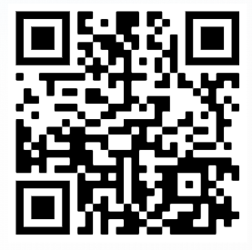 | Times Table Rockstars:  Keep practicing your times tables over the summer so you are ready for the MTC in June.  
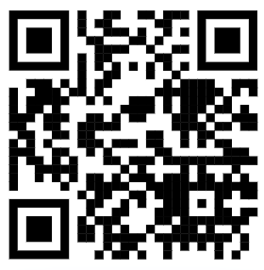 | MTC Practice:  So you are ready for the MTC tests and have a go with some practice.  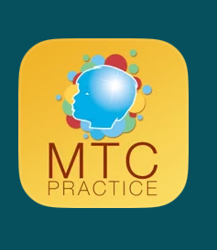

What can you expect in Autumn 1?

English:
Descriptive writing using metaphors and similes. Writing newspaper reports. Biography (writing in third person).

Maths: Number, place value, addition and subtraction, measure-area, multiplication and division.

Science: Animals including humans.

History: Roaring Romans.

Computing: Computing systems and networks – The Internet.

Art/DT- Structure/3D

RE: Why do some people think that life is a journey? What significant experiences mark this?

PSHE- Jigsaw- Being me in the world.

PE: Cricket/Basketball

