
Year 2 Summer Project 2025
Children choose which activities to try and how many to do. Children may also come up with their own ideas, even if it is not on this sheet. Remember to read every day!
  Read & Create  After finishing a book, choose a creative follow-up:  - Make a puppet of the main character  - Draw a new cover for the book  - Write a letter to the character | Create your own exercise or dance routine! 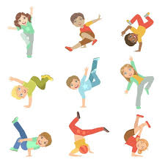 | 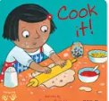  Cook a dish with an adult. Can you write a set of instructions for your class?  Use Time connectives. |   Challenge a friend to a battle on TT Rock Stars.
  Summer holiday snapshots.  Complete 5 drawings of your summer holidays. Write a diary entry for one of these snapshots. | Go on a nature walk - spot 5 different plants or insects.  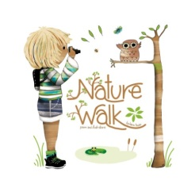  Sketch a detailed drawing. | Learn as many spellings from the year 2 spelling list.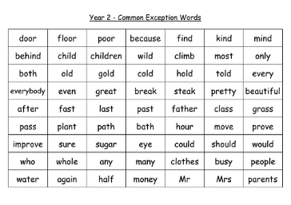 | Grow something in your garden or in a pot!  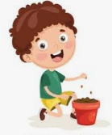  Observe changes - Keep a Seed diary.
Create your own Board Game!  Design and play a simple board game with your family.  Write a ‘How to Play’ Guide to go with it.  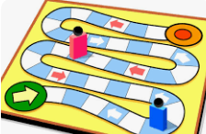 | Create a fact file about your favourite animal.  Why not create a set of ‘Top Trumps’ cards - rate your animals!  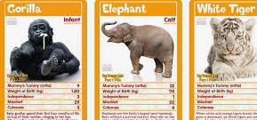 | Create a treasure map. Write instructions using directional language – Use compass points!  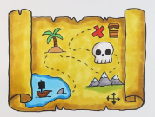 | Make a tally chart.  Ask your family and friends what their favourite fruit is.  Make a Summer salad!  Measure! Chop! Cut! Grate!  

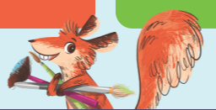
This summer there will also be a reading challenge at Walthamstow library

