
Welcome to Year 2!
Be Brave, Be Kind, Be YOU!
To make you feel prepared and excited to start your new class in September, we have included some information for you to get to know your new year group.
Meet the Team

Teachers:
Moorhen - Mrs Hussain (Year 2 and Humanities Lead)
Magpie - Dr Goodchild
Merlin – Mrs Chetty
Mallard – Mrs Hussain and Mrs Islam

Support Staff:
Dean, Tahira, Hamana, Claudia, Keda (HLTA), Eve, Deana

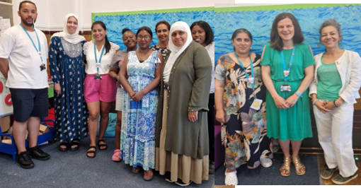

Welcome to Year 2 – A Year of Discovery, Adventure and Wonder!
Get ready for an amazing journey through time and journey across the globe in Year 2! This year, we’ll dive into fascinating topics that will spark your curiosity and help you understand the world around you. We will explore the UK and its surrounding seas. Travel back to 1666 and relive the drama of the Great Fire of London – Find out how a tiny spark changed a whole city, and meet the brave people who helped put out the flames. Fly to Kenya on a fact-packed adventure! Compare life in this beautiful African country to our own lives in the UK and discover its amazing animals, traditions, and culture. Communication – Then and Now – Imagine a world without texts or emails! We’ll explore how people shared messages in the past and how technology has changed the way we connect today. Wonders of Walthamstow, we will become local explorers! We’ll celebrate the incredible places and people of our community and find out what makes Walthamstow so special. Ever wondered what school was like in the past? We’ll uncover the stories and secrets of our own school’s history. Florence Nightingale & Mary Seacole, meet two heroic women who changed hospitals forever. Discover how their kindness and courage helped save lives during times of war.
This year will be packed with fun activities, exciting trips, brilliant books, and creative challenges. So grab your learning hat and a big smile – Year 2 is going to be unforgettable!

To help you prepare, below are a few suggestions to get you ready:
Read, Read and Read some more! Why not visit your local library and enter the Summer Reading Challenge. Over the summer holidays, keep a writing journal, write about daily events, help write the shopping list or let your imagination run wild and write your own stories! Practice forming your letters correctly. Are your letters sitting on the line? Are your tall letters (ascenders) tall and tails (descenders) sitting under the line? How many Year 2 Common Exception words can you spell correctly? Can you count to 100 and then count back? How many different ways can you make the number 20? Don’t forget to log onto TT Rockstars!

Read
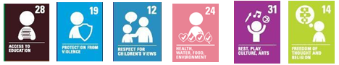
What can you expect in Autumn 1?
English:
Descriptive writing focusing on adjectives and expanded noun phrases, using inspiration from the sea!
Maths: Numbers to 100, Addition and Subtraction
Science: Living Things and their Habitats
Geography: Name and locate the world’s seven continents and five oceans, identify characteristics of the four countries and capital cities of the United Kingdom and its surrounding seas, understand geographical similarities and differences through studying the human and physical geography of a small area of the United Kingdom.

Computing: Information Technology around us
Art/DT- Seascape Painting
RE: Who is a Christian and what do they believe?
PSHE- Jigsaw- Being me in the world.
PE: Sending and Receiving, Target Games
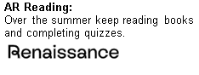
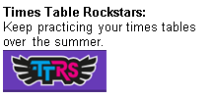
In Autumn 1 we will be reading…


