Mission Grove  2023-2023 | Autumn 1 | Autumn 2 |  | Spring 1 | Spring 2 |  | Summer 1 | Summer 2
Year 3 | Coming to England | UG: Boy genius of the Stone Age |  | Krindlekrax | Planet Omar |  | Awesome Egyptians | Pugs of the Frozen North
Year 3 | 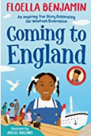 | 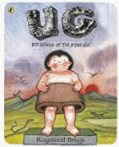 |  | 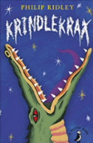 | 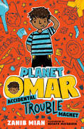 |  | 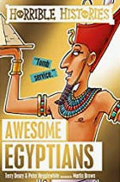 | 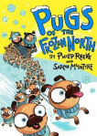
Author | Floella Benjamin | Raymond Briggs |  | Philip Ridley | Zainab Mian |  | Peter Hepplewhite | Phillip Reeve
Genre | Fiction / Non-fiction | Fiction |  | Fiction | Fiction |  | Non – fiction | Fiction
Text type | Autobiography | Historical comic |  | Thriller | Humour |  | History | Adventure / humour
Writing Outcome | Post card writing  Diary entry  Letter writing | Narrative  Setting description  Instructional writing |  | Letter writing  Newspaper report | Poetry  Narrative description  Character description  Fact files |  | Historical writing Information texts  Non-chronological report | Writing in role Character profile Leaflets and posters  Narrative
Link texts |   Non-Fiction  ’40 facts about Trinidad & Tobago’ | 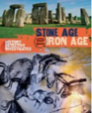  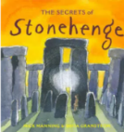  Non-Fiction  ‘The Secrets of Stonehenge’ by Manning & Granstrom  ‘Stoneage boy’ by Satoshi Kitamura  24 hours in the Stone Age by cook & Kling |  | 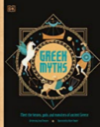  Greek Myths: Theseus and the Minotaur/ St George and the Dragon | 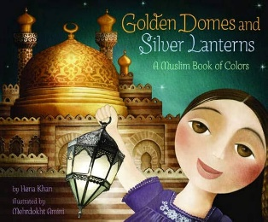  Golden Domes and Silver Lanterns, Hena Khan and Mehrdokht Amini (Chronicle Books) |  | 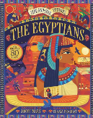  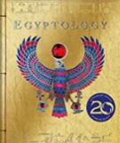  Non-Fiction  ‘So, you think you’ve got it bad: A kids life in Ancient Egypt’ by Straithe & Morea  ‘100 facts Ancient Egypt’ by Miles Kelly | 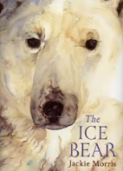  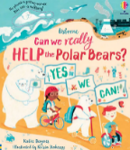  ‘The Last Polar Bears’ by Harry Horse  ‘The Journey Home’ by Frann Preston-Gannon
Cross-curricular links | PSHE: Changes | History: Stone Age |  | Science: living things | Geography: Rural settings/ farming |  | History | Geography: Environment/ WWF
Poetry
Books to share |  |  | Poems to learn & perform |  |  | Poems to read and enjoy
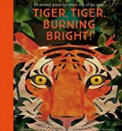  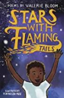  Tiger, Tiger Burning Bright – Fiona Waters  Stars with Flaming Tails - Valerie Bloom  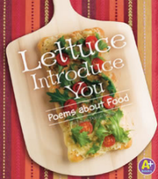  Myon – Lettuce Introduce You: Poems about food |  |  | The Sound Collector – Roger McGough  A stranger called this morning  Dressed all in black and grey  Put every sound into a bag  And carried them away  The whistling of the kettle  The turning of the lock  The purring of the kitten  The ticking of the clock  The popping of the toaster  The crunching of the flakes  When you spread the marmalade  The scraping noise it makes  The hissing of the frying pan  The ticking of the grill  The bubbling of the bathtub  As it starts to fill  The drumming of the raindrops  On the windowpane  When you do the washing-up  The gurgle of the drain  The crying of the baby  The squeaking of the chair  The swishing of the curtain  The creaking of the stair  A stranger called this morning  He didn't leave his name  Left us only silence  Life will never be the same  The Adventures of Isabel – Ogden Nash  Isabel met an enormous bear,  Isabel, Isabel, didn't care,  The bear was hungry, the bear was ravenous,  The bear's big mouth was cruel and cavernous.  The bear said, Isabel, glad to meet you, How do, Isabel, now I'll eat you!  Isabel, Isabel, didn't worry,  Isabel didn't scream or scurry.  She washed her hands and she straightened her hair up,  Then Isabel quietly ate the bear up.  Once in a night as black as pitch Isabel met a wicked old witch.  The witch's face was cross and wrinkled, The witch's gums with teeth were sprinkled.  Ho, ho, Isabel! the old witch crowed,  I'll turn you into an ugly toad!  Isabel, Isabel, didn't worry,  Isabel didn't scream or scurry,  She showed no rage and she showed no rancor,  But she turned the witch into milk and drank her. |  |  | The Tyger (1794) – William Blake  Mr Moore – David Harmer  Ghost in the Garden - Berlie Doherty  If Anger was an Animal - The Emotional Menagerie  My Brother Might be Bigfoot- Kenn Nesbitt  Limericks  The poem is five lines in length and follows the rhyme scheme AABBA. The line structure is as follows:  Line 1: 7-10 syllables;  Line 2: 7-10 syllables;  Line 3: 5-7 syllables;  Line 4: 5-7 syllables;  Line 5: 7-10 syllables.  The first line usually begins with ‘There was a…’ and ends with the name of a person or place. The last line should be rather unusual or far-fetched.  Each line starts with a capital letter. Lines often end with a comma. The mood of this type of poem is comic, and it can even be nonsense  Year 3 Example:  There once was a boy called Joe  Who dropped a big brick on his toe  He asked, with a frown “Will the swelling go down?” And the doctor said, “Yes, I think so.”  Clerihew  A clerihew is usually a humorous poem written about a specific person. It is a four-line comic verse with two rhyming pairs of lines with the rhyme scheme AABB. The first line of the poem will include the name of the person about whom the verse is written.  Year 3 Example:  Astronaut Neil Armstrong  Wasn’t on the moon for long.  But in that time he left behind  A giant footprint for mankind.  Free Verse: repetition, rhyme, simile, rhythm  Year 3 Example:  The truth about my imagination  The truth is I imagine I can fly  Like a bird floating through the sky  Soaring up towards a cloud  Overlooking an awe-struck crowd.  The truth is I imagine I am invisible  Like an unseen, undisturbed miracle  Wandering freely wherever I go  No one will ever see me show.

