MissionGrove

P R I M A R Y S C H O O L

RESPECT YOURSELF RESPECT OTHERS

Headteacher Miss Kate Jennings

Mission Grove Spelling Bee 2023 - Year 4, 5 & 6
It’s that time of year again! Attached is the first list of words to learn. These will be the words tested in class, in the week commencing Tuesday, 18th April 2023. The winning children from each class will then participate in a semi-final, before an assembly on Friday, 28th April 2023. You can learn words from the higher years if you want to!
Happy spelling!
Miss Beath
Year 4 words
operate | handicraft | action | publicity | autograph | boring
recall | prove | formula | handful | bicycle | louse
children | autopsy | assist | thief | action | scarves
operate | politician | formula | bicycle | automatic | protein
balance | happiness | recall | dictionary | beautiful | louse
doubt | reference | mystery | depression | government | wives
bicycle | autograph | thief | magician | memorable | ocean
wakeful | package | shakily | jewellery | transplant | vein
tuneless | disapprove | freedom | publicity | shameful | piece

Year 5/6 words
operate | handicraft | action | publicity
recall | prove | formula | handful
children | autopsy | assist | disobedient
machinery | passenger | imprisonment | depression
doubtful | beautiful | government | certificate
politician | possession | education | abominable
happiness | medieval | neighbour | protein
auditorium | mystery | secretary | parliament
reference | memorable | dictionary | contribution

autograph | boring | discipline | magician
bicycle | louse | reclaimable | compromise
assistance | examination | transatlantic | sovereign
approval | imbalance | forgiveness | responsible
circulation | cellophane | institution | furthermore
jewellery | illiterate | marriage | graphic
inconvenient | aquarium | hopeless | hungrily
handkerchief | emptiest | variety | boastful
profession | centipede | alliance | imbalance

You can also search for other spelling words on the Years 3/4 and Years 5/6 spelling list online.

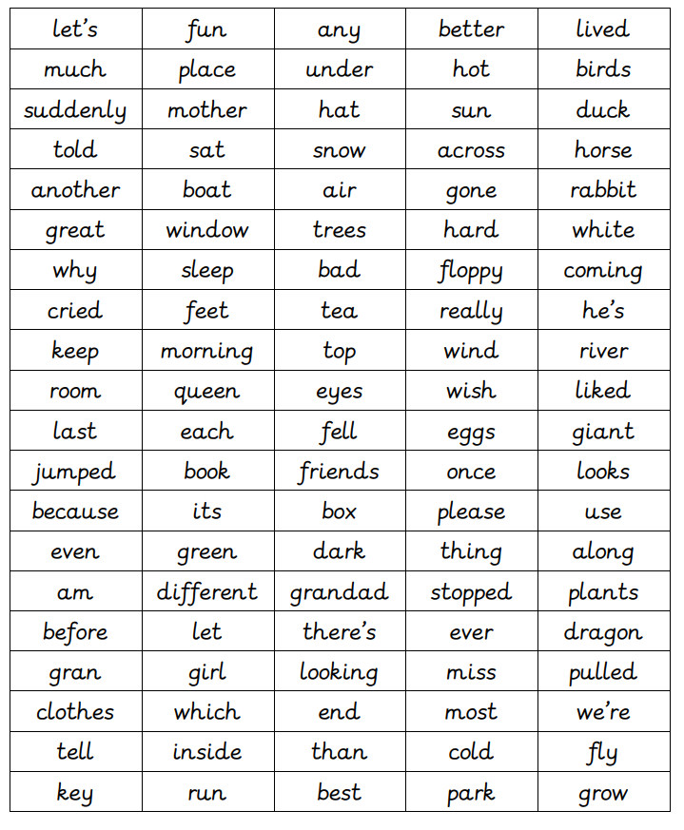
Remember, you will be asked different words for the semi-final and final so get practising!

introduction | although | additional | independence | continent
sequence | challenge | material | techniques | Expensive
significant | innovative | remained | indigenous | diverse
distinct | versions | instances | flourishing | Caribbean

