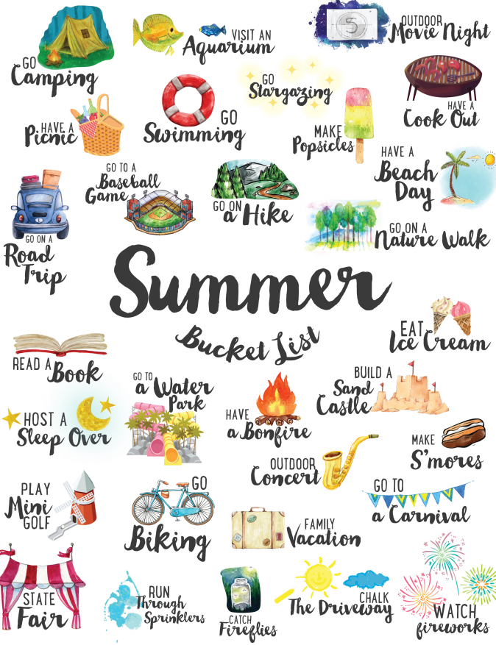
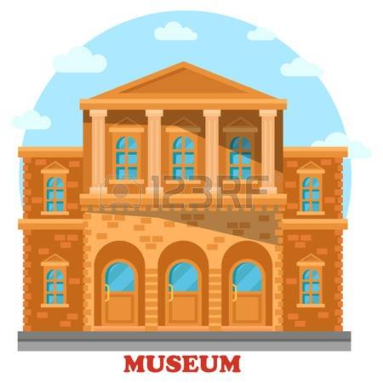

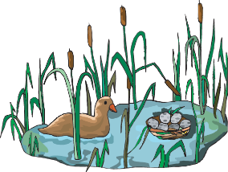

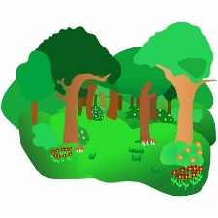
Walthamstow Wetlands
How many of these summer challenges can you complete?
Record your adventures by writing, drawing a picture, or taking a photograph to show us when you return to school.
DISCOVER A NEW
Museum
Summer Reading Challenge
COMPLETE THE
OBSERVE WILDLIFE AT
Treat
BAKE A
Epping Forest
EXPLORE

