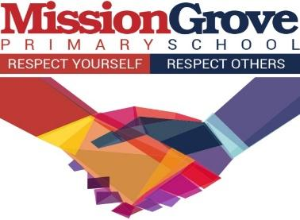
Art Progression Map
"The arts are not a luxury. They are as crucial to our well-being, to our very existence, as eating and breathing. Access to them should not be restricted to a privileged few. Nor are they the playground of the intelligentsia. The arts are for everyone – and failure to include everyone diminishes us all."
Sir David Attenborough
Intent
At Mission Grove Primary School, the teaching and implementation of the Art curriculum is based on the National curriculum and linked to topics to ensure a well-structured approach to this creative subject. Our Art curriculum provides children with the opportunities to develop and extend skills and an opportunity to express their individual interests, thought and ideas. A high-quality art education should engage, inspire and challenge pupils, equipping them with the knowledge and skills to experiment, invent and create their own works of art, craft and design. As pupils progress, they should be able to think critically and develop a more rigorous understanding of creative arts. They should also know how art and design both reflect and shape our history, and contribute to the culture, creativity and wealth of our nation. Our intent in Art is that all our children receive their entitlement and frequent access to art as laid out in the national curriculum, to inspire and enthuse children’s imagination and appreciate ‘creative arts’ and to enhance children’s learning by having opportunities for collaborative working and exploring the different styles and techniques of a range of artists. We break Art down into four key skill requirements: studying classical and modern great artists, designing and planning, awareness of different arts, crafts and design, and evaluating / analysing. Our teaching builds upon pupils’ prior knowledge and develops a range of skills using observation, research, questioning, identifying and investigating.
Implementation
The arts are highly valued at Mission Grove, with creative thinking and achievements part of the fabric of school life. Knowing the ever-changing reality of educational climates, we are committed and prepared to ensure that involvement in the arts continues to be accessible to all our pupils. This is achieved by threading the arts throughout each school day. We offer a creative curriculum, in which Art is embedded within a bigger picture, linked to the topic of the term. This supports our pupils with being able to showcase their skills in a range of ways across the curriculum as well as encouraging the viewpoint that subjects are not taught in isolation.
We provide students with a multitude of arts and cultural experiences and develop good partnerships with external organisations. Our ethos values teachers being creative and getting out of the classroom. We encourage experiential learning and have exciting areas within our school that cater to this, for instance: the Biodome in our wildlife area, our Green Screen, Radio room and Library buses. We regularly plan for exciting visitors and trips linked to the creative arts. Examples of trips and visitors this year include:
- Year 1 and 2 had a performance from sixth form drama students at City and Islington college
- Year 2 and 4 had a Dance workshop from Dance Days linked to their topics (The Great Fire of London and Egypt)
- Some of our Year 5 children took part in a workshop at Plaster Works where they gave old plaster board a new lease of life.
- In December our Year 4 students worked with local artists to create neon windmills which were displayed in Walthamstow library during Highstreet ADVENTures, a local festival
- Every year group visited our local cinema to watch a film during the Into Film festival.
Across the year there are a range of whole-school events to celebrate and showcase the arts. These include:
- Film week
- STEM week
- The Big Draw
- Sky All Access Arts week (Matt Dosa)
- Our biennial School Art exhibition
- Remembrance Day
- Weekly enrichment hour whereby children select activities on a half termly basis. Many are creative arts based, for example, animation, cartoon drawing, sewing, origami, radio, music, printing and karaoke to name a few.
- We offer children lunchtime and afterschool clubs that range from art club to circus skills.
End of unit goals are shared with the children so that they know where their learning is heading within each topic studied. This also supports them with making links across Art.
Impact
Using our termly planning and curriculum overviews; our lessons are planned to enable children to have every opportunity to build upon their prior knowledge and consolidate their understanding.
The impact of our Art curriculum is that the majority of children, in our school, are able to;
- produce creative work, exploring their ideas and recording their experiences
- become proficient in drawing, painting, sculpture and other art, craft and design techniques
- evaluate and analyse creative works using the language of art, craft and design
- know about great artists, craft makers and designers, and understand the historical and cultural development of their art forms.
- By the end of each key stage, pupils are expected to know, apply and understand the matters, skills and processes specified in the relevant programme of study
Teachers assess children’s work in Art by observing them work during lessons. Verbal feedback is offered throughout the lesson, whilst not compromising a child’s creativity. Art work is marked or responded to at the end of the unit of work in each child’s Art sketchbook, with teachers providing comments which refer to the child’s use of the skills and techniques taught. Formative assessment is embedded into each lesson in the form of evaluating their own work and of others, discussions and plenaries. Termly Teacher judgement using Insights.

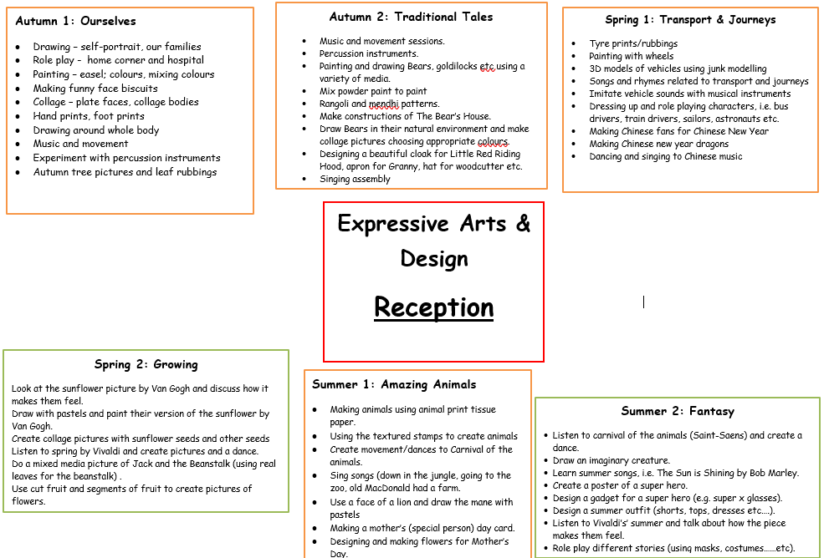

Art Programmes of Study: Key Stage 1 and 2 National Curriculum
Key Stage 1:
Pupils should develop a wide range of art and design techniques. They should be taught to use a range of materials develop knowledge about the work of range of artists, develop and share their ideas and make products.
Pupils should be taught to:
Great artists | Know about the work of a range of artists, craft makers and designers. Describing the differences and similarities between different practices and disciplines, and making links to their own work.
Designing and planning | To use a range of materials to creatively to design and make products.
Awareness of different arts, crafts and design | To develop a wide range of art and design technique in using colour, pattern, texture, line, shape, form and space.
Evaluating and analysing | To use drawing, painting and sculpture to develop and share their ideas, experiences and imagination.

Key Stage 2:
Pupils should be taught to develop their techniques, including their control and their use of materials, with creativity, experimentation and an increasing awareness of different kinds of art, craft and design. Pupils should be able to think critically and develop a more rigorous understanding of art and design.
Great artists | To learn about great artists, craft makers, architects and designers in history. To understand the historical and cultural development of their art forms.
Designing and planning | To create prototypes in sketch books to record their observations and use them to review and revisit ideas.
Awareness of different arts, crafts and design | To develop their techniques and improve their mastery of art and design techniques, including drawing, painting and sculpture with a range of materials.
Evaluating and analysing | To evaluate and analyse creative works using the language of art, craft and design.

Curriculum overview
Art forms part of Mission Grove’s Creative Curriculum. The learning in Art is linked to a key theme for that half term.
See attached separately roadmap for Art.
Year group | Autumn 1 | Autumn 2 | Spring 1 | Spring 2 | Summer 1 | Summer 2
Year 1 | Theme: Food Glorious Food  Artist: Acrimboldo and Matisse  Skills: drawing, blending using oil pastels, printing, collage  Lesson Outcomes:  Draw and shade a piece of fruit.  Use oil pastels to create a still life  Painting fruits  Printing with fruit  Creating a Matisse inspired collage | Theme: Amazing adventures  Artist: Andy Goldsworthy  Skills: Collage  Lesson Outcomes:  To appreciate the artists work  Natural sculptures  To select materials and make spirals or circles.  Collaborative collage artwork | Theme: Toys  Artist: Gwen Johns  Skills: drawing  Lesson Outcomes:  To draw carefully and accurately  To be able to carefully apply a wash to a picture.  Careful cutting and arrangement of pieces to create a collage.  Applying skills to drawing with a wash their own favourite toy.  Trip: Vestry House museum | Theme: Our perfect planet  Artist: Julie Kagti  Skills: Textile  Lesson Outcomes:  History of weaving  Explore methods of manipulating fabric and yarns by poking, pulling, threading and weaving (cardboard)  Paper weaving  Paint a landscape on plate  Tree weaving | Theme: Rainforest  Artist: Henri Rousseau  Skills: Drawing and painting  Lesson Outcomes:  Sketching skills: plants and flowers  Create their Portrait-Landscape picture.  Design animals masks.  Re-create painting in the style of Rousseau (tiger) | Theme: Under the sea  Artist: Romero Britto  Skills: Sculpture / 3D  Lesson Outcomes:  To use wax resist technique.  To see how to create a simple picture illusion.  To develop colour mixing and careful painting technique as well as using collage.  Using clay to create a turtle.  To create a picture or simple sculpture in the style of Romero Britto.  To use a variety of different materials effectively, making reasoned choices.
Year 2 | Theme: Great Fire of London  Artist: David Best  Skills: Drawing, painting,  Lesson Outcomes:  To create a colour wheel  To understand cool and warm colours.  Paint a background to represent the Great Fire.  Sketching tudor houses | Theme: Land Ahoy  Artist: Sonia Lawson  Skills: drawing, shading, painting  Lesson Outcomes:  Exploring watercolor techniques  To learn variety of brushstrokes (paint the sea and skies)  Japanese Origami (sailboats)  add textures and shades | Theme: Wonderful Walthamstow  Artist: Vincent Vangough  Skills: 3D structures / Textiles  Lesson Outcomes:  Examine paintings to discuss features.  Manipulate range of materials  Sketch Sunflower  Add 3d (scrunching paper and layering)  Evaluate work  Trip: National Gallery | Theme: Nurturing Nurses  Artist: Picasso  Skills: Textiles and Collage  Lesson Outcomes:  To Examine paintings and discuss features  To understand what makes a good collage  Draw a portrait in the style of Picasso  Picasso portrait collage  Collage of Mary seacole or Florence Nightingale | Theme: Plants  Artist: Andy Warhol  Skills: Printing, drawing  Lesson Outcomes:  Shades of Green  Nature printing  Mono printing  Leaf printing Art  Flower print art | Theme: Kenya  Artist: Sarah Munyai,  Skills: sculpture / 3d, painting  Lesson Outcomes:  To explore Africa, its colours, shapes and patterns.  To explore Maasai jewellery and culture.  To sculpt a Clay pinch pot  To add African design to our clay pot
Year 3 | Theme: Tobago  (Geography)  Artist: Modigliani  Skills: Drawing  Lesson Outcomes:  To draw a face accurately and in proportion.  To use charcoal and chalk to complete a half face picture.  To use a range of materials – pastels.  To learn about designs in nature & used in different cultures | Theme: The Human Body (Science)  Artist: Paul Cezanne  Skills: Painting  Lesson Outcomes:  Sketching technique, showing light and shadow through use of blending.  Colour mixing use of complementary colours.  To experiment with the effects of pointillism.  To experiment with the effects of watercolour paint.  Trip: National Gallery - Still life workshop | Theme: Stone Age  Artist: Upper Palaeolithic Art  Skills: Textile / collage  Lesson Outcomes:  Features of Stone age clothing (materials)  Creating a Tunic  Cave paintings  Stitching a design on the Tunic | Theme: Weather  Artist: Colin Self  Skills: Printing  Lesson Outcomes:  Explore Printing (monoprinting)  Basic printing  Sketch out 4 seasons  Add First print  Second Print | Theme: Romans  Artist: Sosus of Pergamon  Skills: Sculpture / 3d  Lesson Outcomes:  To Explore Roman Mosaic (annotate)  To Make clay tiles  To Paint the tiles  To Create mosaic design  To Evaluate work | Theme: London  Artist: Stephen Wiltshire  Skills: Textile / collage  Lesson Outcomes:  To Explore the art of Stephen Wiltshire  To use a range of mark making techniques  Create a London skyline using a pencil sketch  Add collage
Year 4 | Theme: Ancient Egyptians  Artist: Ancient Egyptians  Skills: Sculpture / 3d  Lesson Outcomes:  To understand what Canopic Jars were used for  To be able to design a personal Canopic Jar (add hieroglyphics)  To use modelling techniques to create an armature.  To use mod roc with accuracy  Design the canopic jar  Trip: British Museum | Theme: Electricity and machines  Artist: Hirotaka Hamasaki  Skills: Drawing/ shading  Lesson Outcomes:  Explore the features of portraits  Focusing on a particular feature  Create a basic outline  Add detail  Shade with pastel and chalk | Theme: Express yourself  Artist: Kandinsky  Skills: Painting/ shading/ collage  Lesson Outcomes:  Combine colour and shapes  Explore how mood can impact artist expression  Explore how the art itself can differ in mood | Theme: Anglo Saxons  Artist: Bayeux Tapestry  Skills: sculpture / 3d  Lesson Outcomes:  Become aware of historic differences in style of art, culture and clothes.  Learn about differences in style of jewellery.  Craft historical broach. | Theme: Brazil  Artist: Romero Britto  Skills: Drawing / textile  Lesson outcomes:  Create still life sketches of the flora and fauna found in Brazil.  Annotate Romero Britto Art work  Understand pop art  Collaborative rainforest animal or art work in the style of Britto | Theme: Brazil  Artist: Vasare Nar  Skills: Printing/ collage  Lesson Outcomes:  Annotate Animal prints  Focus on one print  Sketch and design  Printing
Year 5 | Theme: Ancient Sumerians/ Varjak Paw  Artist: Dave McKean  Skills: Drawing (line, tone, colour), sketching, mark making  Lesson Outcomes:  Sketching in the style of David McKean: drawing and practising sketching, lines, shade and tone techniques.  Explore and use different marks used by the Ancient Sumerians | Theme: Ancient Greece  Artist: Lucie Rie  Skills: Sculpture/3D  Lesson Outcomes:  Researching Lucie ria and exploring different vase designs  Making a Greek Vase using recycled materials  Adding mudroc to the vase  Painting the Vase with repeating pattern  Adding detail to the vases | Theme: Viking Boy  Artist: Samira Addo  Skills: Drawing, sketching  Lesson Outcomes:  To explore Viking art and identify its key characteristics and features.  To annotate facial features of a Viking.  To be able to draw a portrait of a Viking warrior.  Add final touches (watercolour, oil pastels) | Theme: Street Child  Artist: William Morris  Skills: Printing  Lesson Outcomes  Investigating the work of WM and collecting visual information  Developing the design and selecting colours  Experimenting with repeating patterns  Printing  Reviewing and evaluating  Trip: William Morris Gallery | Theme: Earth and Space  Artist: Peter Thorpe  Skills: collage  Lesson Outcomes  Researching abstract artists and focus on Peter Thorpe.  Experimenting background colours using collage (mix and match colours to create atmosphere and light effects)  Researching rocket designs  Creating final piece of background using collage inspired by Peter Thorpe and drawing rocket.  Reviewing and evaluating | Theme: Stormbreaker  Artist: Peter Lanyon and Adam Sebire  Skills: Textile and painting  Lesson Outcomes:  Warm and Cold colours  Annotate features of Thermal photos  Taking Thermal photos  Sketch photograph  Use colours to represent thermal painting
Year 6 | Theme: Extreme environments  Artist: Vincent Van Gogh/Georgia O'keeffe  Skills: Painting  Lesson Outcomes:  Consider artists’ use of colour and application to develop their own style  Explore texture of paint  create painting of chosen environment-  identify colours: colour of tone, warm and cold colours  texture of paint (thick/thin/wet/heavy (add pVA)  use acrylic paint to create interesting pieces. | Theme: WW2  Artist: John Piper  Skills: Drawing and painting  Lesson Outcomes:  Create a line drawing of the old Cathedral  Creating a painted depiction of Coventry Cathedral in the style of John Piper  Studying The Poppy  Creating a painted picture of The Poppy | Theme: Shakespeare  Artist: Cindy Sherman  Hieronymus Bosch  Skills: Painting/Portraiture  Lesson Outcomes:  Exploring traditional Tudor portraits (drawing for prolonged periods)  Using costume to complete a self-portrait in the style of Cindy Sherman | Theme: Japan  Artist: Ukiyo-e  Hokusai  Skills: Printing and drawing  Lesson Outcomes:  Visual elements of different Japanese art styles  To be able to carve printing blocks  To learn about the Japanese art of Manga  To learn how to draw faces in a Manga style  To create a Daruma Doll | Theme: Healthy walthamstow/ local history  Artist: Banksy/  Hunto: https://www.widewalls.ch/artists/hunto  Picasso  Skills: Collage  Street painting/ cubism  Lesson Outcomes:  History/origins of cubism  identify colours: colour of tone, warm and cold colours  Political Art  Trip Tour of Walthamstow to take photos of various street art, appraise and discuss  Trip to Tate gallery | Theme: Year 6 Production  Artist: Virgil Abloh  Skills: Textile and sculpture / 3d  Lesson Outcomes:  Use a variety of materials to create various set designs, props and costumes.  Link with sewing club - supporting in making costume

