Purpose of sketchbooks
Mission Grove Primary School
Sketch Book Policy
A sketchbook is an important personal record used:
• To gather, collect, experiment and reflect
• To assess children’s skills and progression in art and design
• As a way for children to express themselves and their creativity
How to use sketchbooks
• Sketchbooks should be owned by the pupils. As such, sketchbooks should be individual and develop personality, therefore a class of sketchbooks should not look the same.
• Sketchbooks should be used to show a journey of progression of an art unit. There should be clear development and build of skills/knowledge/techniques that lead to a final outcome/piece of art.
• Sketchbooks do not have to be used in every art lesson. Sometimes it is not appropriate to use sketchbooks in an art lesson, for instance; sculpture/3D art, display work or when you need a bigger canvas than A4.
• Where practical work is done, photo evidence can be stuck into the sketchbooks. Children can write about what they did, the skills they used, what they enjoyed and any feedback they shared with you. This can effectively demonstrate the ‘evaluate’ and ‘reflect’ part of art and design.
• Sketchbooks should continue with the child throughout school in order to show progression of skills throughout their school journey.

What sketchbooks should look like
• Children should take pride in their sketchbooks but they do not have to be beautifully neat and tidy. It should be considered a working document and some pieces of work may appear messy or even chaotic. What may appear messy to us could be that child’s best effort.
• Mistakes should be encouraged to not be rubbed out or removed, but instead be seen as part of the learning process.
• Children should paint, chalk, oil pastel, collage and print directly into the sketchbooks unless a bigger canvas than A4 is required. If a final piece is required for display, then a photo of the final piece should be evidenced in their sketchbooks.
• Sketchbooks can be used as a place to collect: - Photographs - Photocopies of art work - Pictures from magazines, cards, calendars etc. - Samples of fabric, textures and materials. - Poems or stories that may have been used to stimulate a response
Marking Sketchbooks
• Marking should not comment on how good the work is. Marking should be positive and constructive and link to the key skills/techniques being taught. Examples of effective marking in sketchbooks: “Great use of shading here, I like the way you’ve made the object look 3D” “The colours you have used here are really effective”
• Teachers do not need to mark directly into sketchbooks. They should use discussion to provide verbal feedback, or mark on a post it note/paper and attach to work.
• Teachers do not have to mark every piece of art work in sketchbooks but should use their own judgements to decide if verbal or written feedback is appropriate

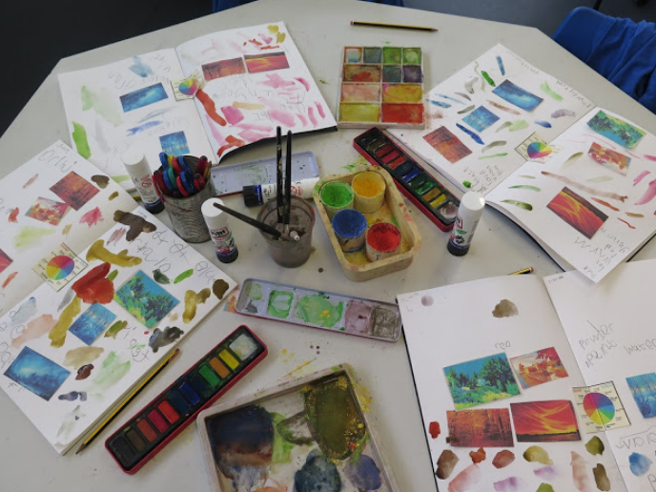
YEAR 1
A simple independent, sorting exercises used with Year 1/2 Children helps to develop their understanding of warm/cold colours and colour mixing. First the children sort images, using a colour wheel as a guide, and then add their own warm and cold colours using watercolours and powder paint. This allows children to use their sketchbooks in an exploratory way.
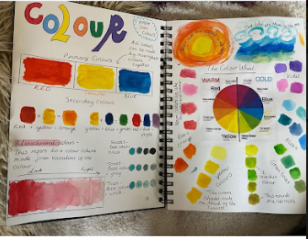
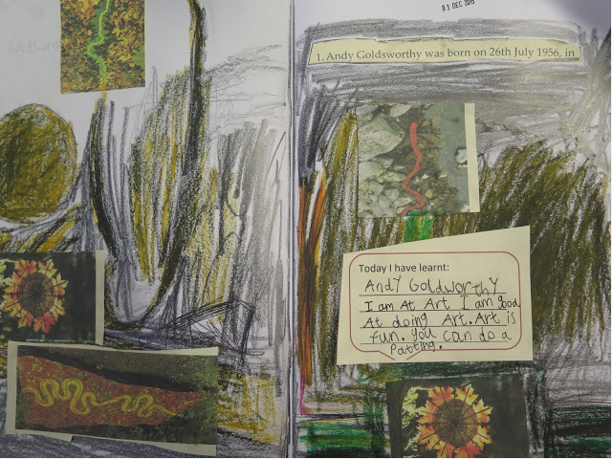
YEAR 2
The tables in the art room were covered with examples of work by artist Andy Goldworthy, along with facts and information about his life and work. The children were asked to use the given information to record what they had learnt about the artist using a range of art media. All the responses were individual and creative. The idea is that children help each other to read the facts and comment on each other’s sketchbook pages.
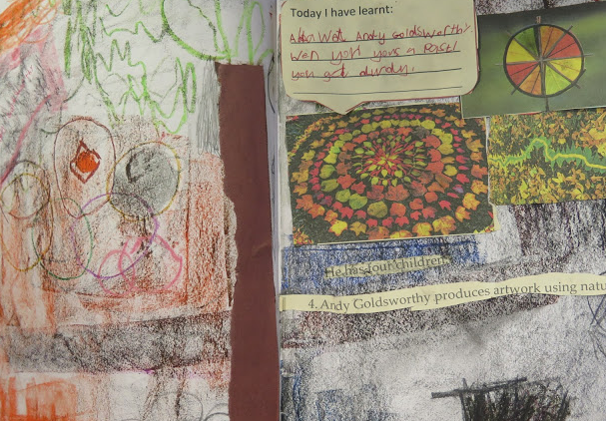
YEAR 3
The key areas we consider when using sketchbooks in year 3 are:
- Gathering inspiration
- Exploring art media
- Developing understanding
- Recording responses
- Reviewing artwork
- Making modifications
- Evaluating
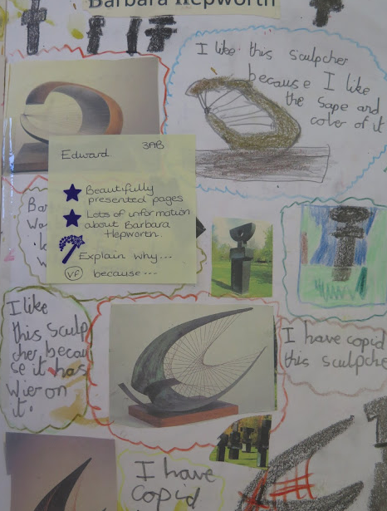

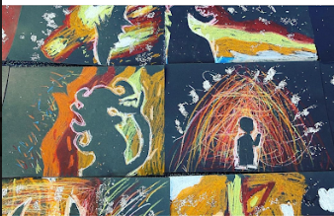

Post-it notes are a great way to add any relevant feedback, from either the teacher or peers, without it being written directly onto pages or artwork.
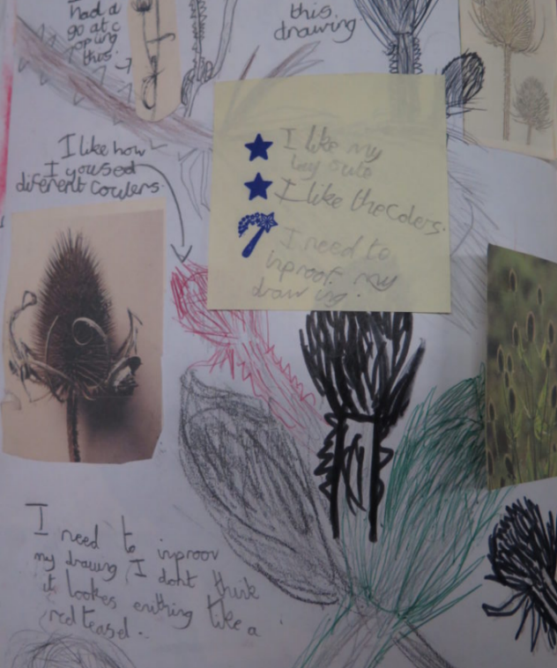

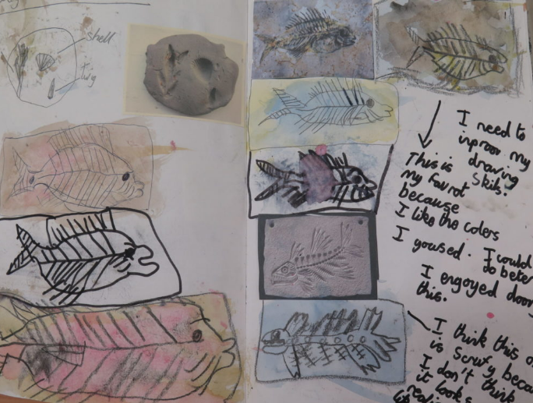

Choice is an important thing to children; it’s a way of being able to express themselves. Whether they are choosing to create something that is the same, similar or completely different to their peers- it is important to allow children to make significant, independent, creative choices throughout their artistic journey. 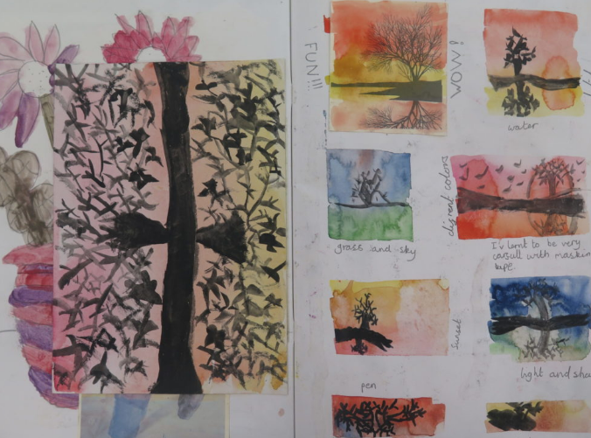
YEAR 4
Children were researching, developing and designing- all linked to a class science project. They learnt about electricity- we considered the impact of pylons on the environment and formulated a project where the children designed their own. The sketchbook pages were very busy with designs and annotations which were then used to inform model making.
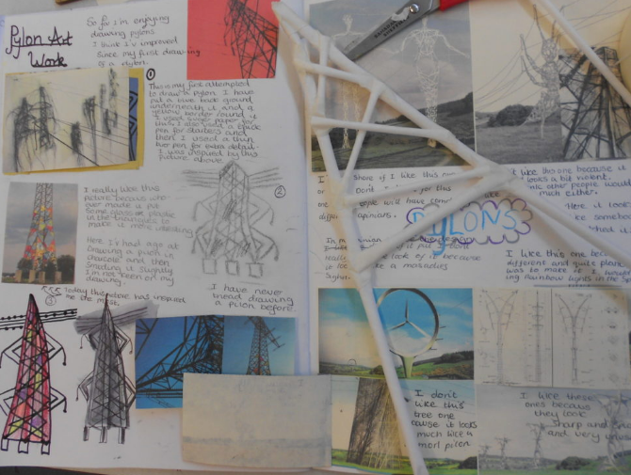

YEAR 5
When working on a portrait project, children used their sketchbooks for a variety of activities. We continually learn and develop our skills of mark making using quick activities. These allow children time to discover new ways to create, consolidate existing skills or to simply explore different art media.
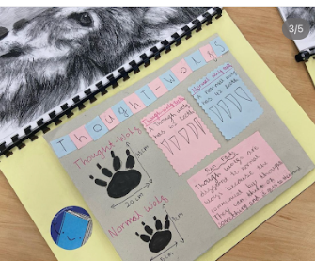
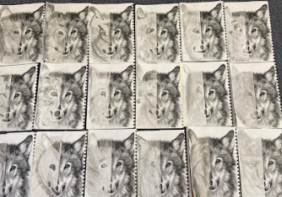
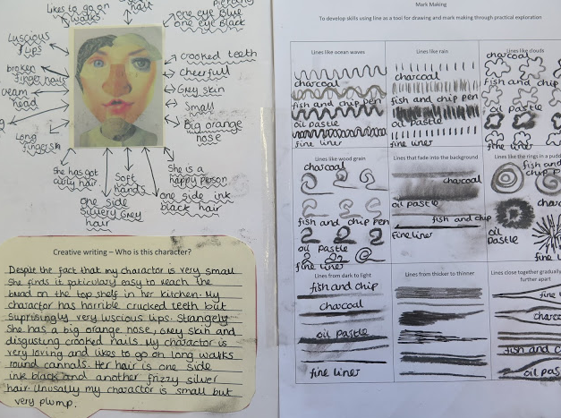
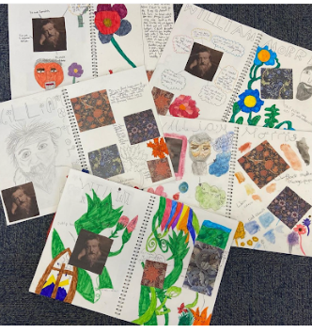
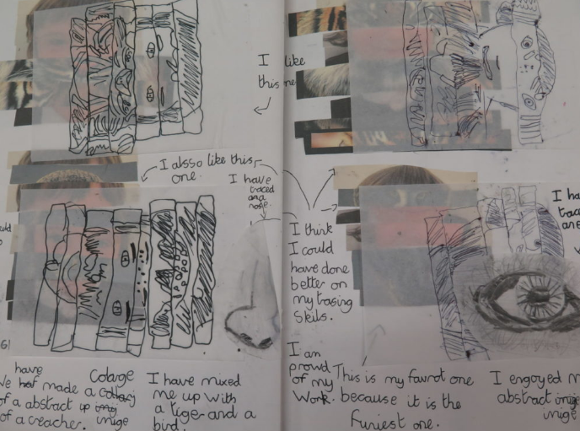

YEAR 6
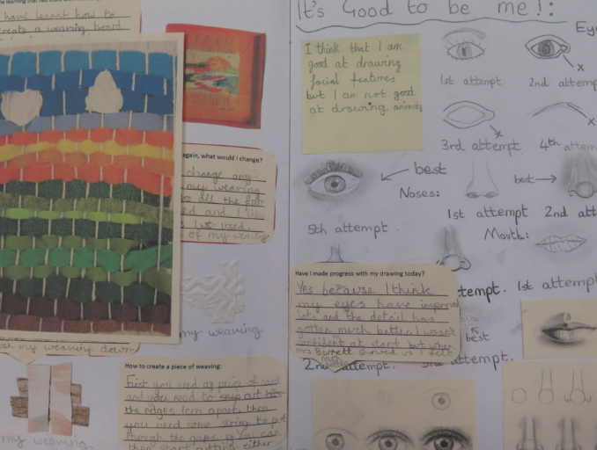
By the time children reach Year 6, they are very comfortable in using their sketchbooks for a variety of purposes. Children are heavily independent and take charge of their own learning using their sketchbook as a vehicle to document their creative journey.
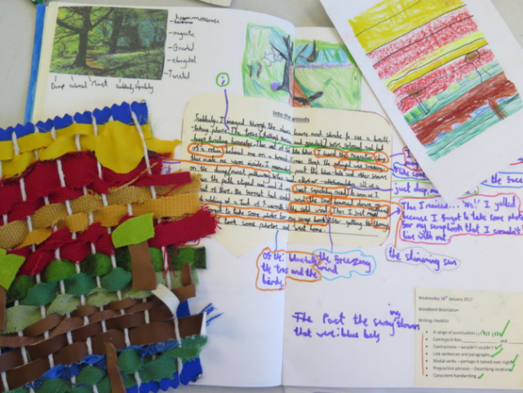

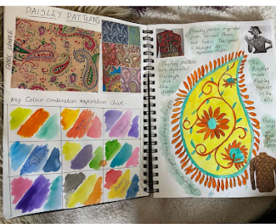

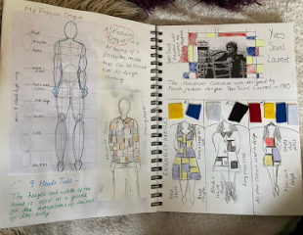

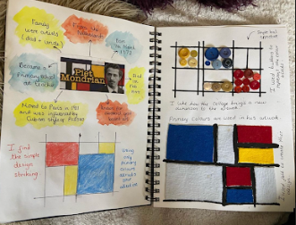
Sketchbooks are a great way to record any progress that is being made within a lesson or a project. We never use rubbers to erase work, instead, we make a series of attempts to document our learning journey.

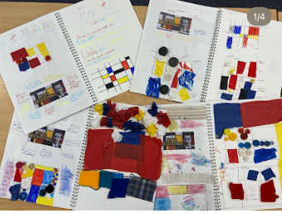

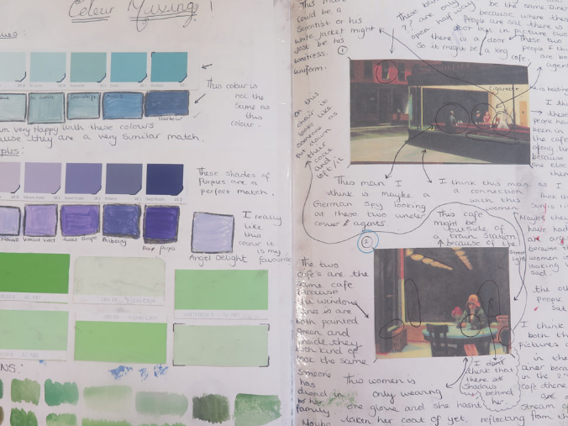

Remember!
In art there are no “wrong answers”.
It is about the process, not the end product.



