Mission Grove Science Policy

Intent
At Mission Grove Primary School, we recognise the importance of science in every aspect of daily life and therefore Science teaching and learning has high prominence. All children will be provided with a broad and balanced science curriculum which reflects the equality and diversity policies and practice in school. Our curriculum enables children to become enquiry-based learners collaborating through asking questions, researching, investigating and evaluating experiences. It will encourage respect for living organisms and for the physical environment. We aim to hook the children’s interest, enabling them to develop a sense of excitement and curiosity about natural phenomena. Throughout the programmes of study, the children will acquire and develop the key knowledge that has been identified within each unit and build on these over the years. Children will be immersed in key scientific vocabulary, which supports in the acquisition of scientific knowledge and understanding. The following types of scientific enquiries are woven throughout our curriculum: Problem Solving, Pattern Seeking, Comparative/Fair Testing, Research, Observation Over Time and Identifying, Grouping and Classifying to ensure that children are gaining a full breadth of opportunities to engage in learning as scientists. All aspects of ‘Working Scientifically’ from the National Curriculum are interwoven throughout our curriculum, again, to ensure that children understand what it means to be a successful scientist.
Implement
Mission Grove Primary has a clear and comprehensive scheme of work in line with the National Curriculum where teaching and learning shows progression across all key stages within the strands of Science and plans for practical investigations All children are catered for through adapted planning suited to their abilities and tailored to interests. Children will be able to build on prior knowledge and link ideas together, enabling them to question and become enquiry-based learners. Where applicable links to Science will be made to develop the children’s topical learning. Teachers demonstrate how to use scientific equipment, and the various Working Scientifically skills in order to embed scientific understanding. The learning environment and teaching strategies help to keep all children engaged and inspire them to want to investigate the world around them, including the school grounds, through group discussions, presentations, demonstrations, videos, practical explanations, experimental work, as well as child-led instruction where this is possible and appropriate. Learning activities focus on developing our children to enquire, observe, locate sources of information, plan investigations, select appropriate equipment and use it safely, measure, record and analyse results and communicate findings. The classrooms display resources (either permanent or for specific lessons) which are used to engage a child’s natural curiosity. An overview of the associated learning opportunities in science are displayed on the subject webpage within the school website.
Teachers find opportunities to develop children’s understanding of their surroundings by accessing outdoor learning and workshops with experts. Children have access to key language and meanings in order to understand and readily apply to their written, mathematical and verbal communication of their skills. Science is delivered by teachers who undergo CPD opportunities as a key part of the ongoing development to incorporate evidence based best practice for teaching this subject. Curriculum planning for science is in three phases: long, medium and short term.
A high proportion of learning science incorporates our children engaging in practical science which allows them to understand a concept, but will also be recorded in a range of appropriate formats that may include:
- written accounts including: instructions, reports and explanations
- illustrations
- annotated diagrams
- spreadsheets (data collection)
- charts, graphs and tables
- model making
- Enrichment activities, such as ‘Science Week’, Borrow the Moon and visitors, promote the profile of Science and allow time for the children to freely explore scientific topics.
Impact
The successful approach to the teaching of science at Mission Grove Primary results in a fun, engaging, high quality science education that provides children with the foundations for understanding the world. Children retain prior-learning and explicitly make connections between what they have previously learned and what they are currently learning and real-life applications using rich science language. Children work collaboratively and practically, demonstrating a high love of mathematical skills through their work, organising, recording and interpreting results. Children learn the possibilities for careers in science and are interested in future study or work in Science fields. So much of science lends itself to outdoor learning, and so Mission Grove provides children with opportunities to experience this.
Assessment at Mission Grove Primary is teacher based and formed using formal strategies (e.g. prior learning assessment tasks, quizzes) and informal strategies (Use of concept maps, verbal/written outcomes, reflection tasks/presentations). Formative assessment is used as the main tool for assessing the impact of Science at Mission Grove Primary as it allows for misconceptions and gaps to be addressed more immediately rather than building on insecure scientific foundations.
Impact of learning will be assessed though: Interviews, deep dives, assessing whether or not children can answer questions about the scientific enquirers and make links to prior learning etc. Formative assessment is embedded into each lesson in the form of evaluating their own work and of others, discussions and plenaries. Teachers use Insights every term to track the child's progress against the different science skills.
Science Curriculum Planning
Science is a core subject in the National Curriculum.
Statutory Requirements: Statutory requirements for the teaching and learning of Science are laid out in, The National Curriculum in England Framework Document for Teaching, September 2014 and the Statutory framework for the Early Years Foundation Stage, September 2021. We are using the 2014 National Curriculum framework to adapt and develop our current planning.
Planning is supported by a number of resources including the ‘PLAN’ Knowledge Matrices, Rising Stars and Hamilton Trust. These resources address the aims of the curriculum and provide teachers with the necessary knowledge to adapt as needed. We carry out curriculum planning in science in three phases (long-term, medium-term and short-term).
The long-term plan maps the topics studied in each term during each key stage; this is created collaboratively between the subject leader and year group teachers to ensure coverage of objectives, progression of skills and avoidance of repetition.
Medium term plans for each subject area are created by teaching staff with an emphasis on the knowledge and skills that will be taught and how they will be taught. Science is taught discretely but staff make meaningful links across subjects where appropriate. Prior knowledge is linked to new learning to deepen children’s understanding and to ensure new concepts and skills are retained. Knowledge organisers are used to share planning with the pupils.
The year group teachers create the short-term lesson plans for each Science session. These plans list the specific learning objectives and resources for each lesson. These are for the year group teachers’ use but may be shared with colleagues, as necessary.
Pedagogy
All teachers have received training to understand its importance in both the planning and teaching stages. In planning and delivering science lessons, we use ‘Rosenshine’s Principles of Learning’ to ensure that the teaching is based on cognitive science and research.
The principles are:
- Begin a lesson with a short review of previous learning
- Present new material in small steps with student practice after each step
- Ask a large number of questions and check the responses of all students
- Provide models
- Guide student practice
- Check for student understanding
- Obtain a high success rate
- Provide scaffolds for difficult tasks
- Require and monitor independent practice
- Engage students in weekly and monthly review.
Teaching methods and approaches
The teaching of science must contain the following:
- Revisit: an opportunity to answer questions with the aim of recapping prior knowledge required for the lesson or topic.

- ‘How to sound like a scientist’: vocabulary instruction designed to equip the children with the scientific vocabulary they will need for the lesson.

- An anchor task: used to present a problem, usually in a real-life context, at the start of a lesson. This engages the pupils, facilitates discussion and provides a useful assessment opportunity for teachers.

- Main Activity: used to focus the pupils’ attention on the key concepts and strategies that will be developed in the lesson. This is usually in the form of a practical activity such as an investigation, a fair test, a drama activity or dialogic discussion.

- Independent written activity: this is to consolidate learning for the children and is used as an assessment tool for teachers. The written activities are completed in the children’s’ curriculum books and can be recorded in many ways such as: annotated pictures/ results of an experiment, written explanations/ conclusions/ results displayed in tables/graphs/ charts, posters or information leaflets
Resources
Science resources are stored centrally and organising according to the area of science they relate to. We recognise the value of using high quality resources and regularly update our stock to meet the needs of the curriculum.
Monitoring and review
Monitoring of the standards of children’s work and of the quality of teaching in science is the responsibility of the subject leader. The work of the subject leader also involves supporting colleagues in the teaching of science, being informed about current developments in the subject, and providing a strategic lead and direction for the subject in the school. The subject leader has specifically allocated time in which to fulfil this role by reviewing samples of children’s work and visiting classes to observe teaching in the subject. They also monitor planning and ensure that the intent for science is being effectively implemented.
A named member of the school’s governing body is briefed to oversee the teaching of science. This governor meets with the subject leader to review progress termly and receives a written report. Where children are to participate in activities outside the classroom, for example, a visit to an outside site, we carry out a risk assessment prior to the activity, to ensure that the activity is safe and appropriate for all pupils.
CPD for staff
Currently per term, there is a Science inset which will be based around strengths and weaknesses picked up on learning walks. For example, there may be an inset based on science working walls, outdoor learning or what greater depth looks like in science. After insets, if targets are set for example science displays then this will be monitored and evaluated. Currently staff have training access to ECM, Reach out and STEM learning.
Assessment and Record Keeping in Science
At the end of each lesson children’s learning is assessed through observations, marking and feedback. Units are taught half-termly and are assessed against the skills from the Insight. It is assumed that all children will make progress because lessons are carefully planned to ensure this takes place. However, any children who are not advancing (not making expected progress) are highlighted in red within Insights and identified through marking and feedback sheets. These children will become a specific focus in future planning. Any children who are working at a deeper understanding are highlighted as blue. We carefully track pupils who are not making expected progress and any pupils who are excelling.
As part of our Science curriculum, each class has a full set of Science Super Hero Squad posters on display. Each Science Superhero character represents one of the lines of enquiry of the ‘Working Scientifically’ section of the National Curriculum, which helps the children to become more familiar with each line of enquiry.

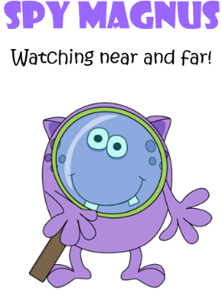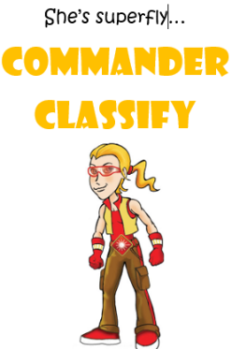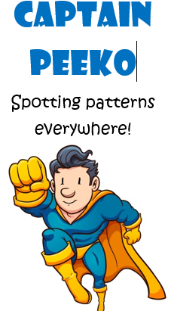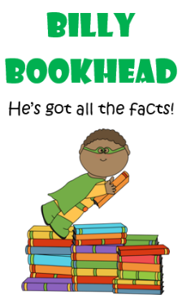
Equal opportunities in Science
• We ensure that all our children have the opportunity to gain science knowledge and understanding regardless of gender, race, class, physical or intellectual ability.
• Our expectations do not limit pupil achievement and assessment does not involve cultural, social, linguistic or gender bias.
• We aim to teach science in a broad global and historical context, using the widest possible perspective and including the contributions of people of many different backgrounds.
• We draw examples from other cultures, recognising that simple technology may be superior to complex solutions.
• We value science as a vehicle for the development of language skills, and we encourage our children to talk constructively about their science experiences.
• We recognise the particular importance of first-hand experiences for motivating children with learning barriers.
• We ensure Science develops children’s creativity; we develop this by asking and encouraging challenging questions and encouraging original thinking whilst ensuring lessons are engaging, purposeful and enriched through visits and visitors.
Put simply we believe depth of learning in Science can be achieved when:
- Children form a relationship with their learning.
- The learning has human significance so it’s relevant to the future decisions and the active contribution our children can make to the world; learning that teaches the children how to live as well as how to learn.
- Collaboration is at the heart learning. Discussion, debate, communication, creativity and critical thinking skills are all valuable currency in an increasing complex world.
- Deeper thinking and reflection are prominent aspects of the curriculum design. Teaching children how to reflect, explain, justify, question are key to lesson design. Learning must be slowed down and focus much less on coverage.
- Teaching children to reflect, explain, justify and question are key to lesson design.
EYFS & Key Stage 1
Observing closely, using simple equipment | What do you notice? What might happen if you…instead of…? Why do you think…happened?
Performing simple tests | How could you test…? Why did you…? Why wouldn’t you…? What would happen if you…?
Identifying and classifying | Why did you put… in this group? Where would…go in your groups? Explain your thinking. Why wouldn’t…go in this group
Using their observations and ideas to suggest/predict | What did you discover? Who might need to use your findings? Why do you think this? How would you prove this idea is right?

Lower key stage 2
Gathering, recording Classifying and presenting data in a variety of ways to help in answering questions | What would be the benefit of repeating your test results? How could I improve my recording? (give example table) How could I present my results in a clear way? Would you use a pictogram, bar graph or line graph to present your ideas? Why?
identifying differences, similarities or changes related to simple scientific ideas and processes | How would this be different if_____________? I think that …. Use your results to explain if I am likely to be right or not? How could I prove it? How would your results apply to ____________?
using straightforward scientific evidence to answer questions or to support their findings. | Bob thinks… Use your results to justify if he is right or wrong.

Upper key stage 2
Using test results to make predictions to set up further comparative and fair test. | Explain your thinking using what you already know. ___ thinks _____ will happen. Do you agree? Explain. How would you improve the test to make sure your results are accurate What questions have arisen from this enquiry? How would you answer/test them? I know want to know____. How could I prove this right or wrong?
Identifying scientific evidence that has been used to support or refute ideas or arguments. | ____ thinks __________, use your results to explain whether they are right or wrong. How did ___ prove ___? Use your learning to explain... How could you prove…. Is right or wrong? Is one piece of evidence enough to justify an idea? Explain your thinking.

Examples of big questions…
What causes gravity?
How do you know the Earth is a sphere?
There are 17 types of penguin on this Earth. Explain why you think this might be.
(When learning circuits…) What is happening inside the wire?
If a tree starts life as a tiny shoot, where does the enormous trunk come from?
Why don’t the sun and moon look the same size in the sky?
I planted a tree in my garden 4 years ago. It now weighs 250kg more. Where did this 250kg come from?
Is a flame alive?
Do all sunflower seeds grow at the same rate?

Learning prompts are used frequently to challenge the children’s thinking and to think outside the box, justifying their responses, often when there are multiple possible responses to a question or statement. For example, the use of ‘odd one out’ tasks where children were given three materials to ponder, as detailed below encourage the children to make links using their pre-existing scientific knowledge and provide reasons for their responses. The use of ‘odd one out’ in science encourages children to think carefully, considering scientific reasoning for the responses often with scenarios where the answer is not always clear, or where there is more than response.
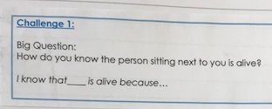
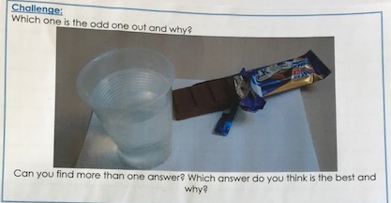
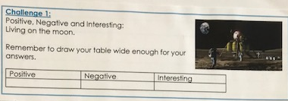
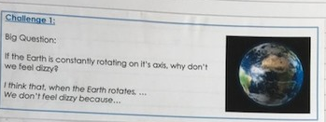

Date to be reviewed: Sep 2024

