MissionGrove

P R I M A R Y S C H O O L

RESPECT YOURSELF RESPECT OTHERS

Headteacher | Miss Katie Jennings

24th September 2026

Dear Parents/Carers,
Year 6 Swimming
As part of the National Curriculum, children should be taught to swim competently, confidently and proficiently over a distance of at least 25 metres. They should learn how to use a range of strokes effectively.
To enable the children at Mission Grove to have the best possible chance of achieving this, we take children throughout their time at school. The swimming sessions will be held in the week beginning Monday 28th September till Friday 2nd October. Please see below timings for your child’s class:
Swan (9 – 10am): Children will need to be at school at 8.15am

Swallow (10am – 11am): Children will need to be at school at normal time.

Skylark (1pm - 2pm): Children will need to be at school at normal time.

Sparrow (2pm - 3pm): Children will need to be at school at normal time and will return to school by 4pm

The children will have lunch at school and travel by public transport or walk to the Feel-Good Centre.
The children will need:
- A towel
- A swimming costume/trunks (not board shorts)
- Goggles
- A swimming hat
- Optional – a small healthy snack- a piece of fruit would be ideal
Please make sure that your child does not wear any jewellery for the week of swimming. If you need help with the equipment please let us know.
Yours faithfully,

Miss Katie Jennings.

North Site | Buxton Rd | Walthamstow | London | E17 7EJ |
South Site | 108 Edinburgh Road | Walthamstow | London | E17 7QB
T : 020 8520 3487 | F : 020 8520 8409 | E : office@missiongrove.org.uk

Towel:

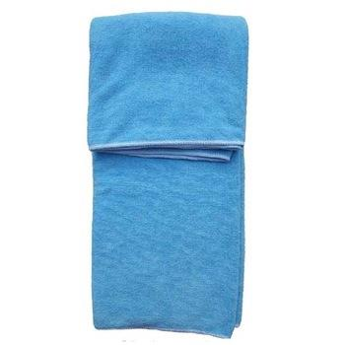

Swimming costume:

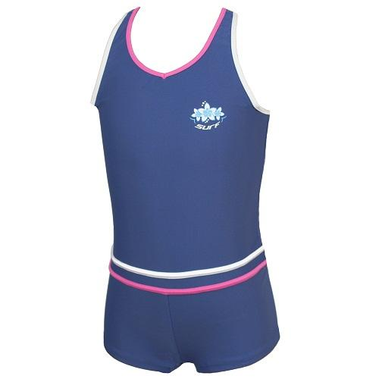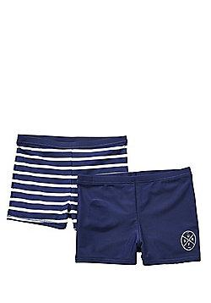

www.missiongroveschool.com

Goggles:

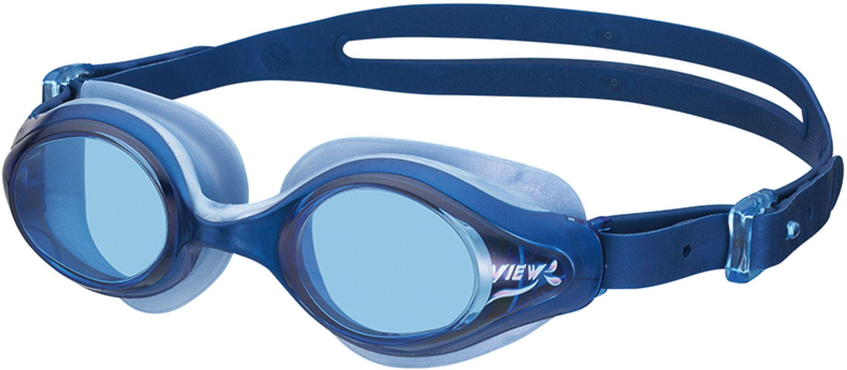

Swimming cap:



